**BCU BEAM Mode Setting**

**1.Run BCU to get a setting and save to a file "1.txt"**

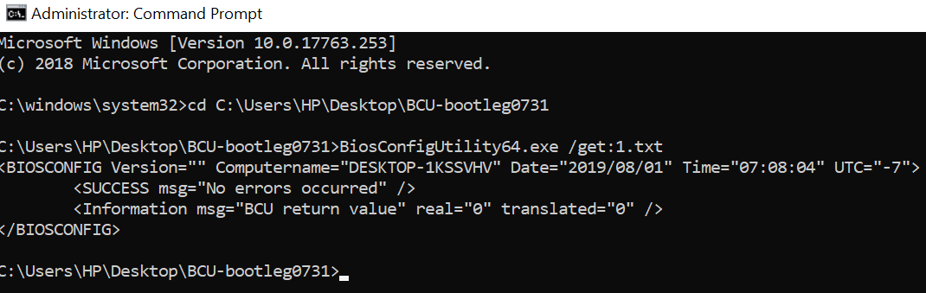

**2.Modify BCU setting file**

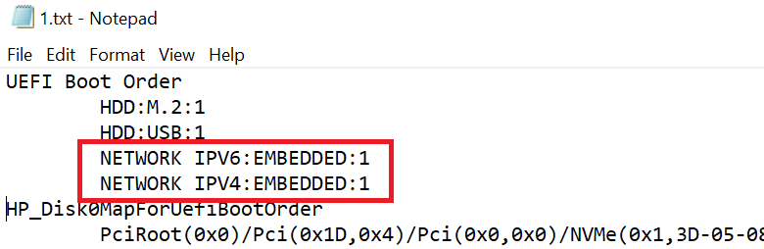

**3.BCU new parameters as below, type "BiosConfigUtility64.exe /?" to get parameters list.**

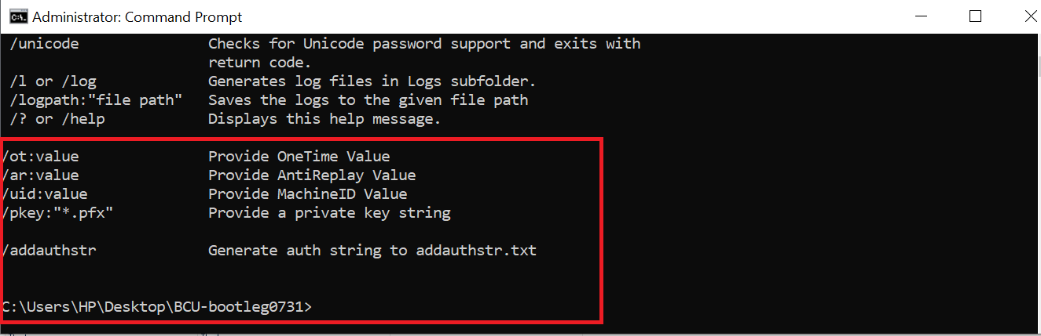

**4.Run BCU with parameter “addauthstr” to save AuthString to a file “BCU-AuthString.txt”.**

**Mode1**. Input all parameters as below

BiosConfigUtility64.exe /set:1.txt /or:0 /ar:0 /pkey:signing\_key.pfx **/addauthstr**

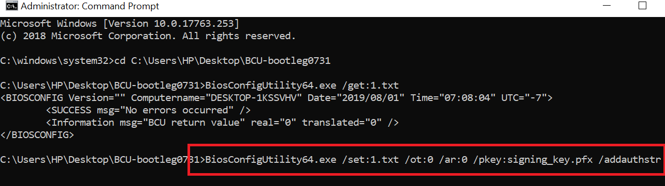

**Mode2**. Using BeamSetting.txt to instead of some parameters.

user also can ignore some parameters and put it to a profile file with name “BeamSetting.txt”.

BiosConfigUtility64.exe /set:1.txt ~~/ot:0 /ar:0 /uid:xxxx /Pkey:xxx~~ /addauthstr

Beamsetting.txt - Notepad 
File Edit Format View Help 
HP Beam mode setting 
Anti ReplayVa1ue=0 
oneTime=o 
Target1D=FF 
privateKey=signi ng_key. pfx 

**5.BCU generate auth string file as below.**

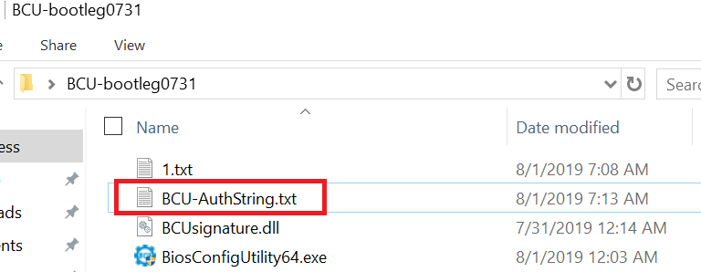

**7.BCU-AuthString file include encripted Auth strings.**

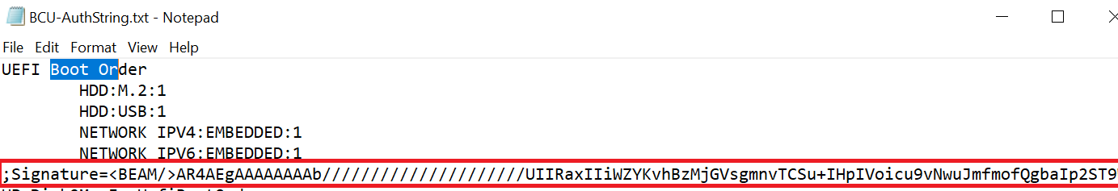

8.**Run BCU to set BCU-AuthString.txt , no need to input others parameters.**

BCU get "Signature strings" and send it to Bios as below.

